**Practical Technical Assessment**

Total Marks: 50 marks Hours: 2hrs30min

Name – Aashika Raj

(NSTIW- Kolkata)

**Tasks:**

1. **Data Preprocessing:**

* Load the dataset.
* Handle missing values.
* Encode categorical variables.
* Scale/normalize the features.

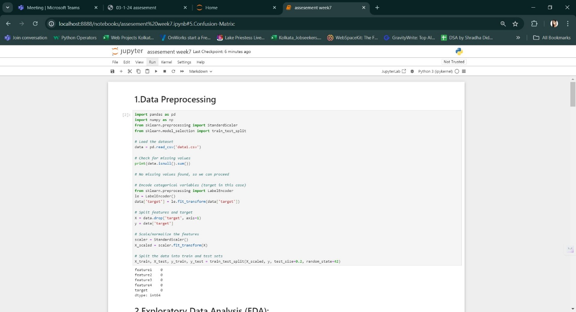

2. **Exploratory Data Analysis (EDA):**

* Provide statistical summaries of the dataset.
* Visualize the data distribution and relationships between features using plots.

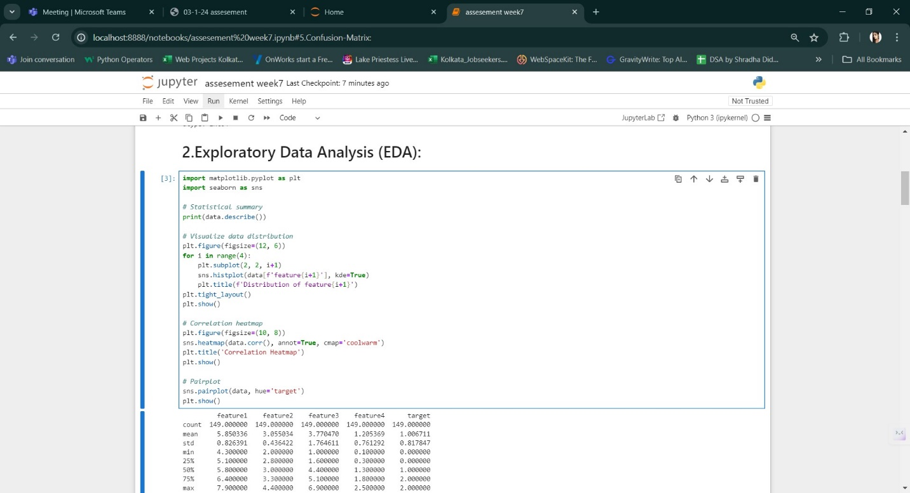

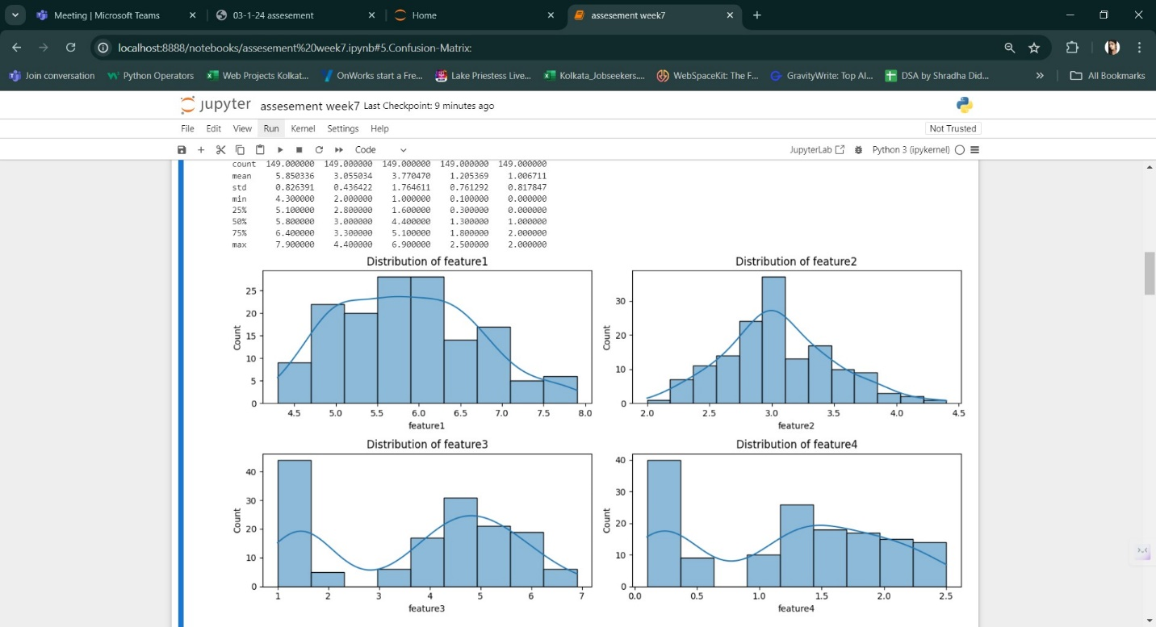

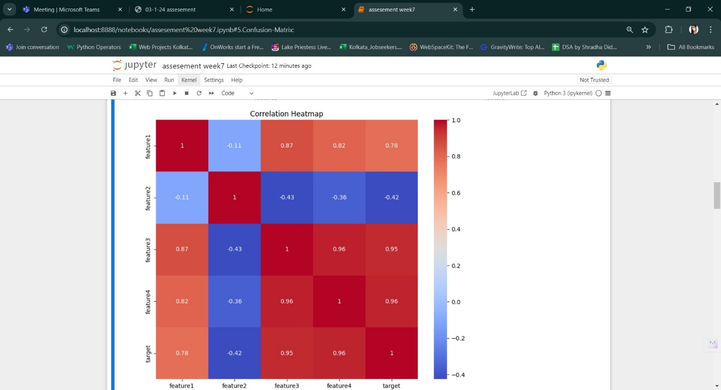

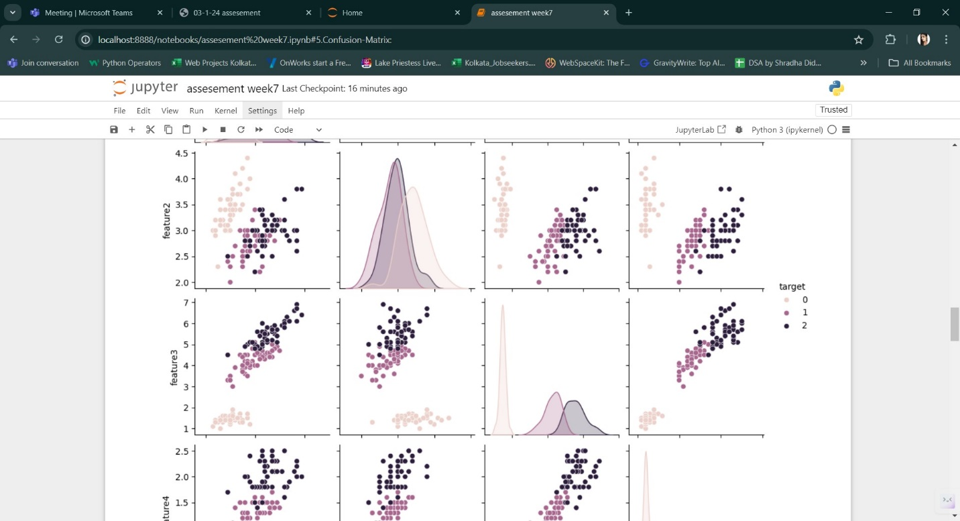

3. **Classification:**

* Apply Logistic Regression, Decision Tree, and Random Forest classifiers.
* Use a confusion matrix to evaluate the performance of each classifier.
* Perform cross-validation to assess the model stability.

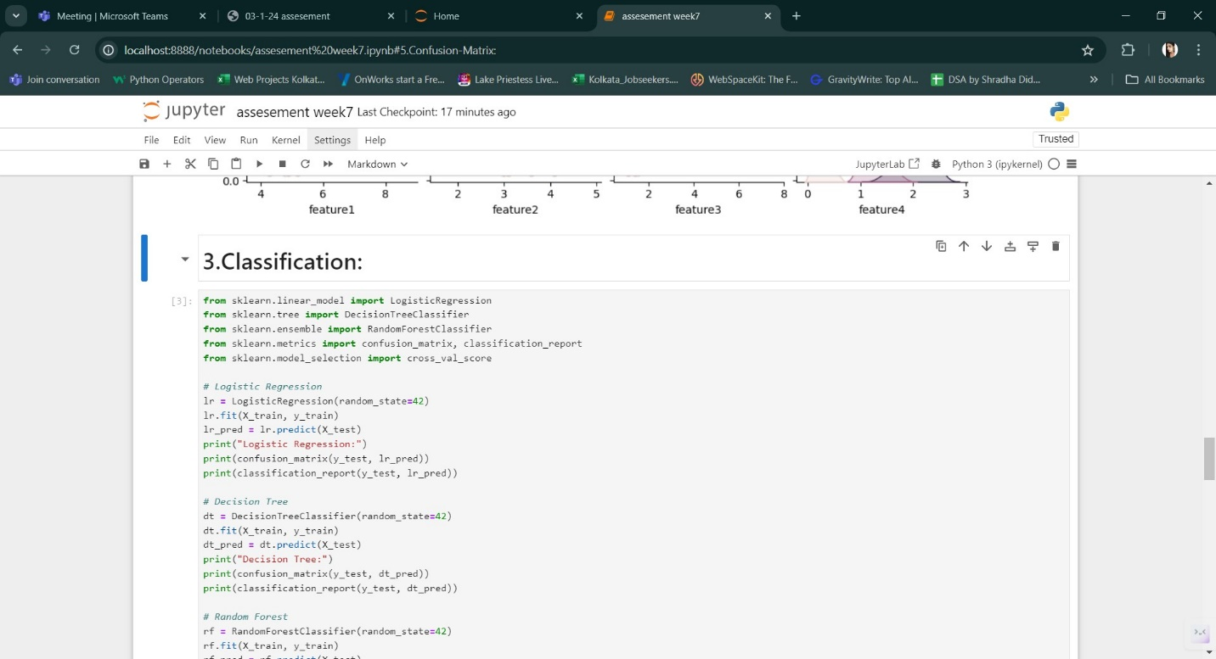

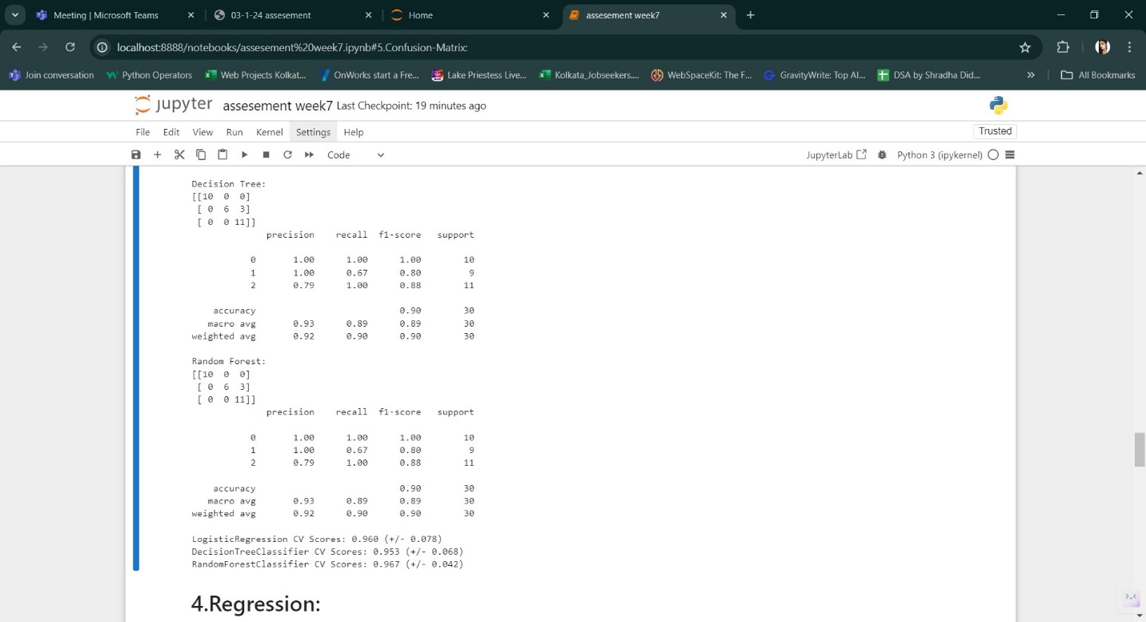

4. **Regression:**

* Apply Linear Regression and Decision Tree Regressor.
* Evaluate the models using R-squared and Mean Squared Error (MSE).
* Perform cross-validation to assess the model stability. 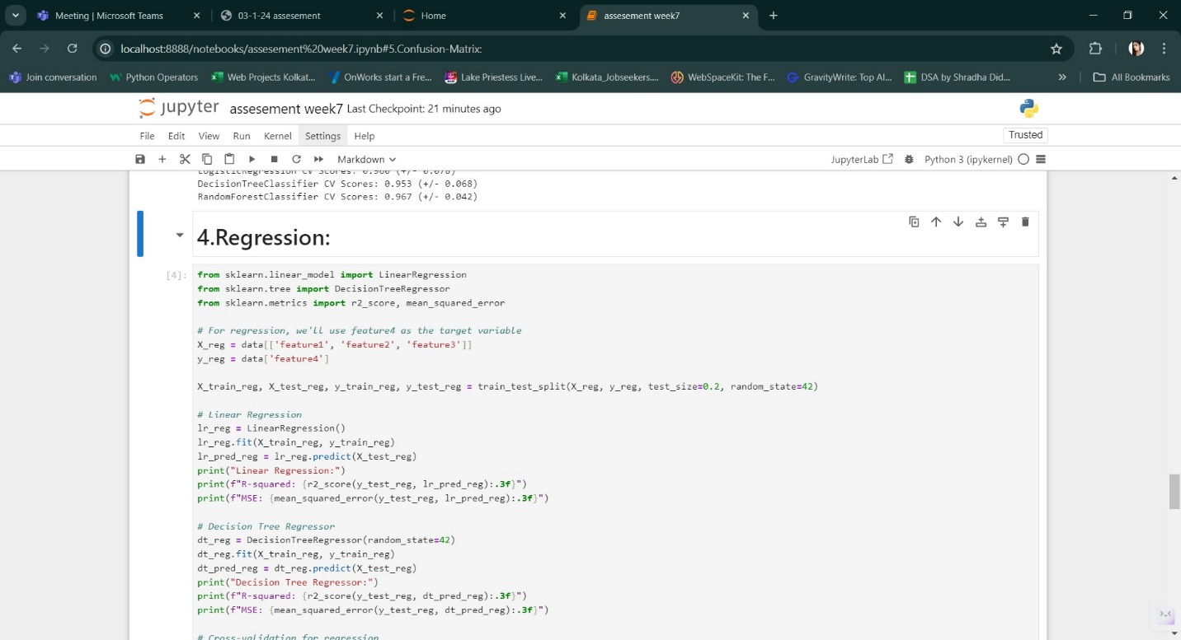

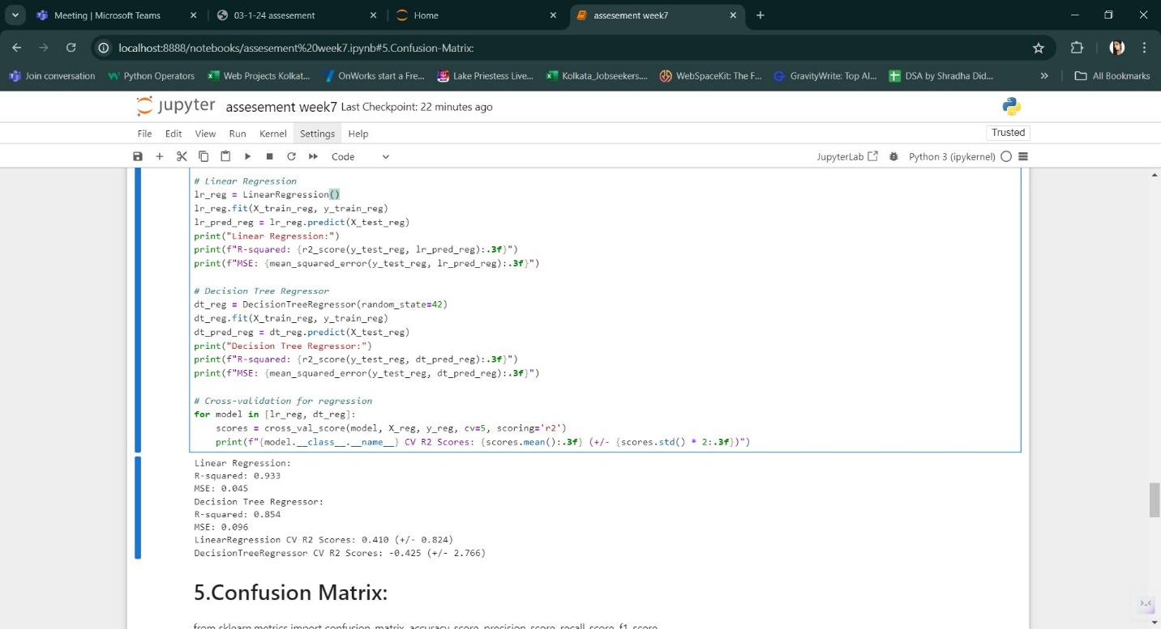

5. **Confusion Matrix:**

* For classification tasks, plot the confusion matrix and compute the following metrics:
* ▪ Accuracy
* ▪ Precision
* ▪ Recall
* ▪ F1 Score

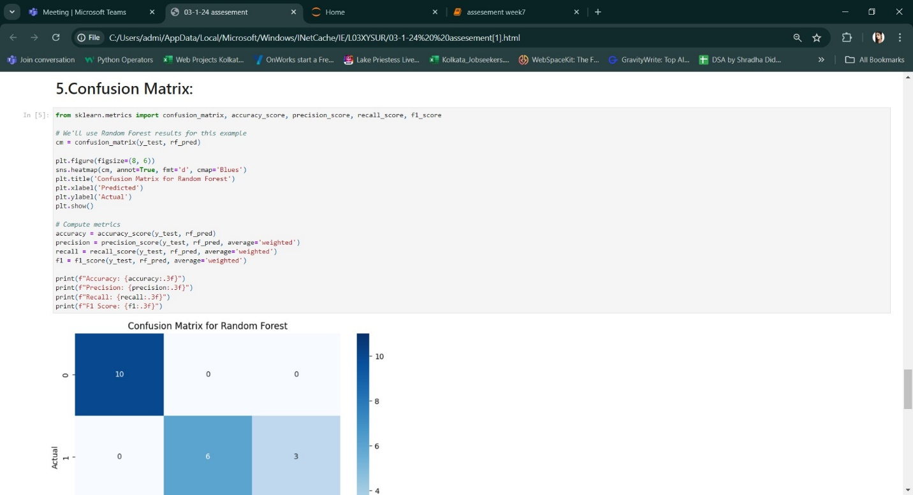

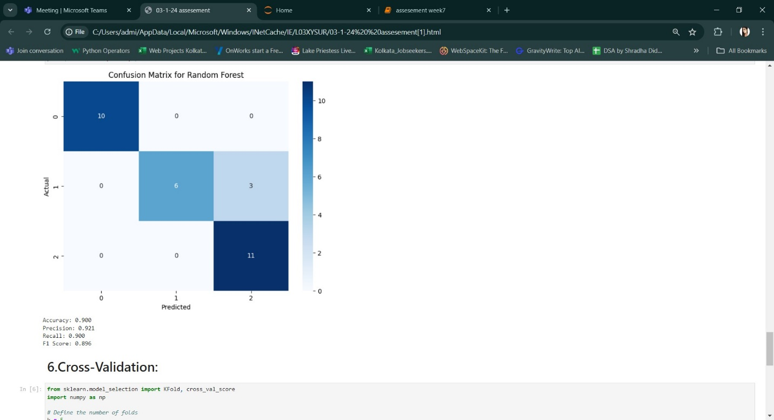

6. **Cross-Validation:**

* Implement k-fold cross-validation for both classification and regression models.
* Report the mean and standard deviation of the cross-validation scores.

